18. Develop a system using UML for Food Order System. In this system, the customer can place orders and purchase items with the aid of the dealer and central food system. These orders are verified and the items are delivered to the customer.

USECASE DIAGRAM :-

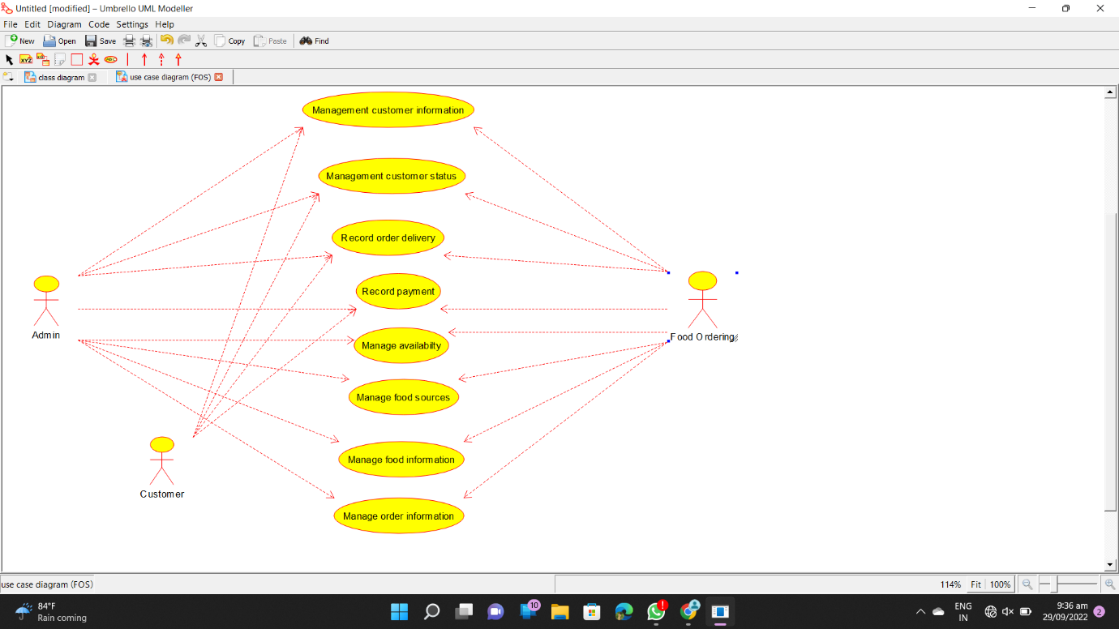

CLASS DIAGRAM :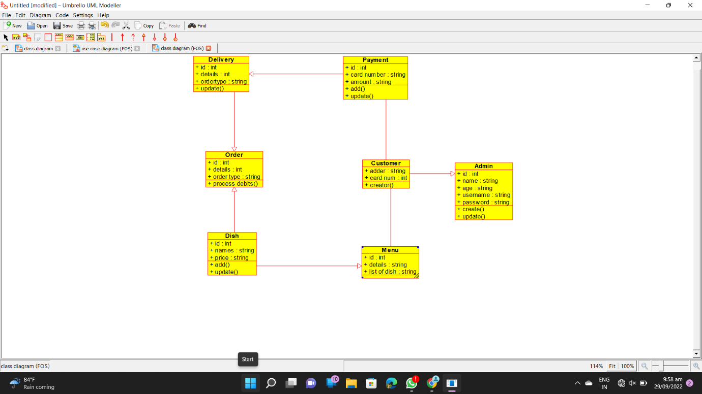

ACTIVITY DIAGRAM :- 